ASSIGNMENT OF MANAGEMENT
TOPIC: SAARC
SUBMITTED TO: SIR OSMAN ALVI
SUBMITTED BY: SAIRA BATOOL 12 ARID 1467
AYESHA MALIK 12 ARID 1410
RABIA JAMSHAID 12 ARID 1458
YUSRA KANWAL 12 ARID 1482

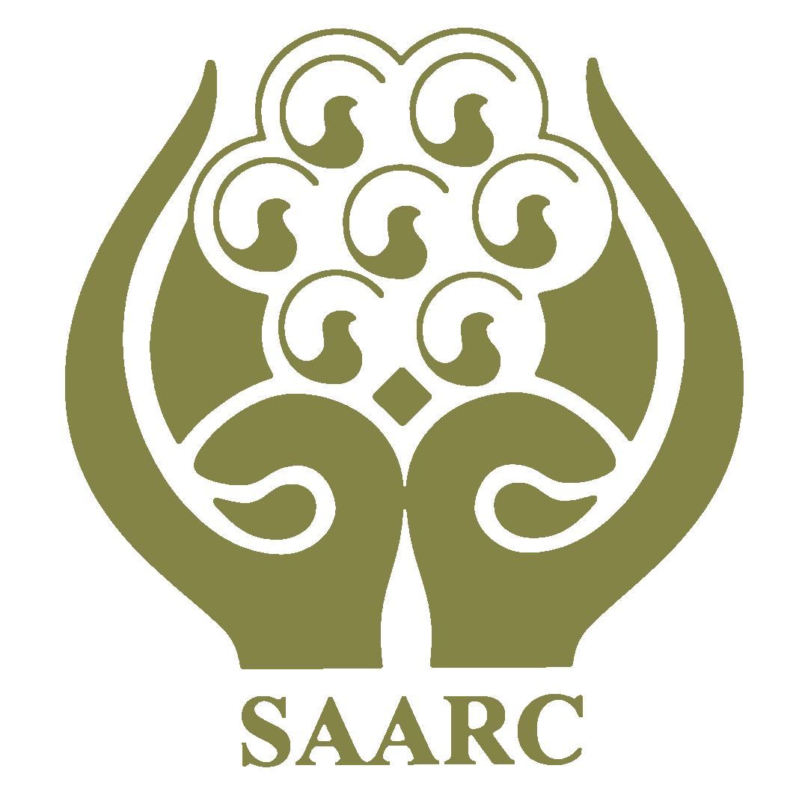
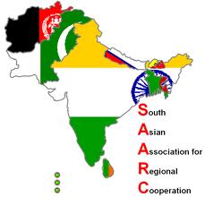

History
The first concrete proposal for establishing a framework for regional cooperation in South Asia was made by the late president of Bangladesh, Ziaur Rahman, on May 2, 1980. Prior to this, the idea of regional cooperation in South Asia was discussed in at least three conferences: the Asian Relations Conference in New Delhi in April 1947, the Baguio Conference in the Philippines in May 1950, and the Colombo Powers Conference in April 1954. In the late 1970s, SAARC nations agreed upon the creation of a trade bloc consisting of South Asian countries. The idea of regional cooperation in South Asia was again mooted in May 1980. The foreign secretaries of the seven countries met for the first time in Colombo in April 1981. The Committee of the Whole, which met in Colombo in August 1985, identified five broad areas for regional cooperation. New areas of cooperation were added in the following years
- COUNTRIES INCLUDED IN SAARC;.
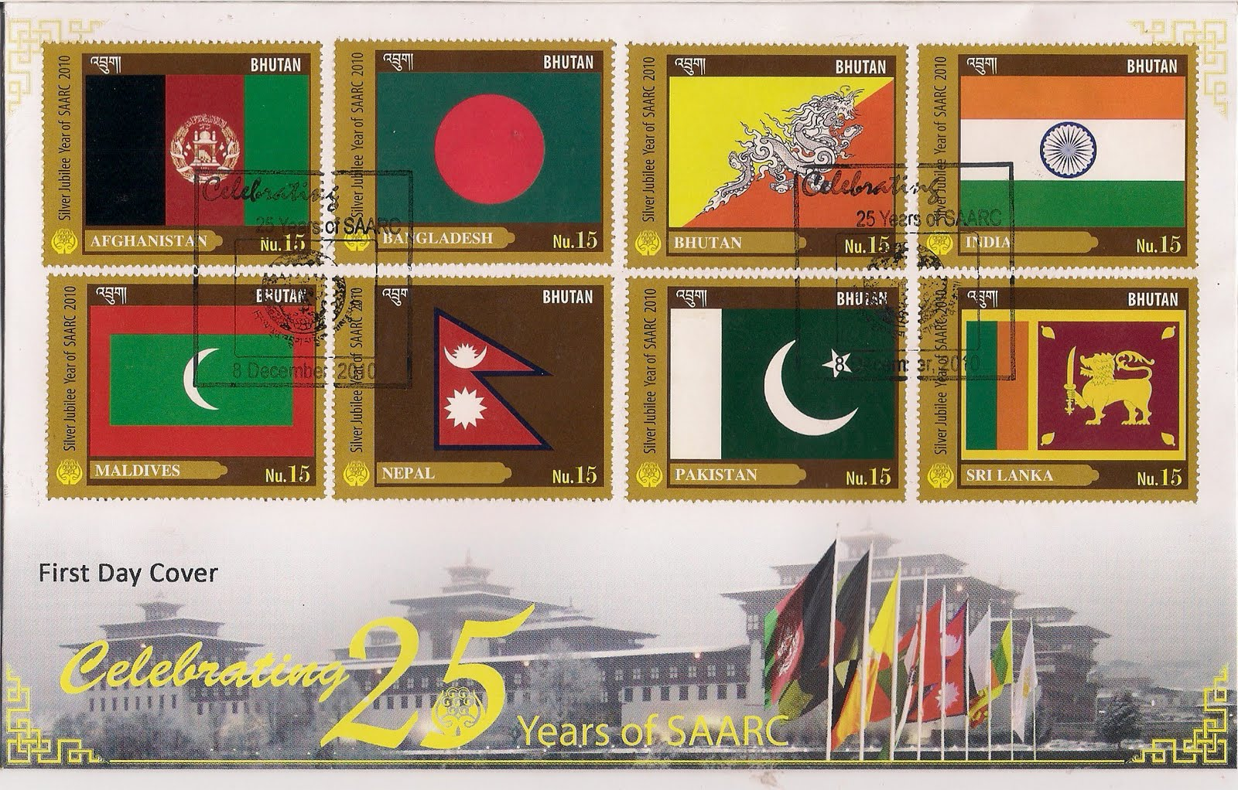

SAARC Member Countries

The South Asian Association for Regional Cooperation (SAARC) was established on December 8, 1985 to organize and unite the governments of of its seven original members: Bangladesh, Bhutan, India, Maldives, Nepal, Pakistan, and Sri Lanka to promote mutual progress and development.

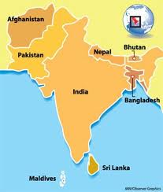
A clickable Euler diagram showing the relationships between various multinational Asian organisations
Current members
- Afghanistan
- Bangladesh
- Bhutan
- India
- Maldives
- Nepal
- Pakistan
- Sri Lanka

- SAARC Documentation Centre:
SAARC Documentation Centre, established in the year 1994, is one of the Regional Centre of SAARC . It acts as an effective information system for the SAARC member states that enables exchange of information in the areas of biological, physical, chemical, engineering and life sciences as well as in developmental matters.

Human resource development is an important activity of SDC. It conducts short term and attachment training programmes in information technology applications for library/documentation/information professionals in the Member States.
- South Asian Association for Regional Cooperation:

The South Asian Association for Regional Cooperation (SAARC) is an organisation of South Asian nations, which was established on 8 December 1985 when the government of Bangladesh, Bhutan, India, Maldives, Nepal, Pakistan, and Sri Lanka formally adopted its charter providing for the promotion of economic and social progress, cultural development within the South Asia region and also for friendship and cooperation with other developing countries. It is dedicated to economic, technological, social, and cultural development emphasising collective self-reliance. Its seven founding members
are SriLanka, Bhutan, India, Maldives, Nepal, Pakistan,and Bangladesh. Afghanistan joined organization in 2007. Meetings of heads of state are usually scheduled annually; meetings of foreign secretaries, twice annually

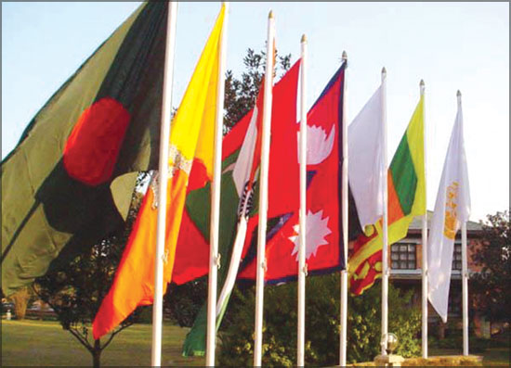
- Objectives Of SAARC
The objectives and the aims of the Association as defined in the Charter are:[3]
- to promote the welfare of the people of South Asia and to improve their quality of life;
- to accelerate economic growth, social progress and cultural development in the region and to provide all individuals the opportunity to live in dignity and to realize their full potential;
- to promote and strengthen selective self-reliance among the countries of South Asia;
- to contribute to mutual trust, understanding and appreciation of one another's problems;
- to promote active collaboration and mutual assistance in the economic, social, cultural, technical and scientific fields;
- to strengthen cooperation with other developing countries;
- to strengthen cooperation among themselves in international forums on matters of common interest; and
- to cooperate with international and regional organisations with similar aims and purposes.
- to maintain peace in the region

List of SAARC summits:

This is a list of summits of the South Asian Association for Regional Cooperation (SAARC). Although the SAARC Charter requires the heads of state or government to meet once a year, the summits have generally taken place approximately every eighteen months.

Economic Relationship among SAARC Nations:

The South Asian Association for Regional Cooperation or SAARC was created to promote economic integrity and cooperation among 7 South Asian nations namely India, Bangladesh, Pakistan, Bhutan, Nepal, Maldives, and Sri Lanka. The Association was formed in 1985 with the aim to ensure social and economic development of the member countries. However, over the years it has been seen that SAARC mainly worked towards development of economic relationship among the SAARC nations. Attempts are also on to further trade relations with the member nations of ASEAN (Association of South East Asian

Nations) and the European Union.
Principles
The principles are as follows;
- Respect for sovereignty, territorial integrity, political equality and independence of all members states
- Non-interference in the internal matters is one of its objectives
- Cooperation for mutual benefit
- All decisions to be taken unanimously and need a quorum of all eight members
- All bilateral issues to be kept aside
- SecretariaT:
Secretariat of the South Asian Association for Regional Cooperation in Kathmandu Nepal
The SAARC Secretariat was established in Kathmandu on 16 January 1987 and was inaugurated by Late King Birendra Bir Bikram Shah of Nepal.
It is headed by the Secretary General appointed by the Council of Ministers from Member Countries in an alphabetical order for a three-year term. He is assisted by the Professional and the General Service Staff, and also an appropriate number of functional units called Divisions assigned to Directors on deputation from Member States.[11] The Secretariat coordinates and monitors implementation of activities, prepares for and services meetings, and serves as a channel of communication between the Association and its Member States as well as other regional organizations.[11]
The Memorandum of Understanding on the establishment of the Secretariat[11] which was signed by Foreign Ministers of member countries on 17 November 1986 at Bangalore, India contains various clauses concerning the role, structure and administration of the SAARC Secretariat as well as the powers of the Secretary-General.
- Political issues
The dispute over Kashmir’s accession to India has been standing in the way of the lasting peace and prosperity of the Indian subcontinent.[13] While awarding the European Union with the 2012 Nobel Peace Prize, the Norwegian Nobel Committee stated that "...today war between Germany and France is unthinkable. This shows how, through well-aimed efforts and by building up mutual confidence, historical enemies can become close partners."[14] Southern Asia can become unified just as Europe has become unified as the European Union. Political dialogue is often conducted on the margins of SAARC meetings which have refrained from interfering in the internal matters of its member states. During the 12th and 13th SAARC summits, extreme emphasis was laid upon greater cooperation between the SAARC members to fight terrorism.
- Secretaries-General of SAARC:
Abul Ahsan January 16, 1985 to 15 October 1989
Kishore Kant Bhargava October 17, 1989 to December 31, 1991
Ibrahim Hussain Zaki January 1, 1992 to December 31, 1993
Yadav Kant Silwal January 1, 1994 to December 31, 1995
Naeem U. Hasan January 1, 1996 to December 31, 1998
Nihal Rodrigo January 1, 1999 to January 10, 2002
Q.A.M.A. Rahim January 11, 2002 to February 28, 2005
Lyonpo Chenkyab Dorji March 1, 2005 to February 29, 2008
Sheel Kant Sharma March 1, 2008 to February 28, 2011
Fathimath Dhiyana Saeed March 1, 2011 to March 11, 2012
Ahmed Saleem March 12, 2012 to present

THE END

