Pindi Books Management System
Presented to: Omair Gull
PREPARED BY: RAHAT MUKHTAR (12-ARID-1459) MUHAMMAD ARSLAN (12-ARID-1442)

Table of Contents
- Introduction
- User Interfaces
- Requirement Analysis
- Key Features
- Committed to Development
- Flexibility
- Customers Comes First
- Home Delivery
- Customers
- Stock Control
- Bookshop Invoicing
- Ordering
- Sales Processing
- Simplify the Procedure
- Goods In
- Backorders
- Book Stock In/Out
- Management Reports
- Technical Support
- Forms
- Physical Design
- Logical Design: E.R.D.
- Hardware and Software Requirements
- Conclusion

INTRODUCTION
Purpose of Report

The purpose of this report is to explain detailed description of Book Management System. It will explain the aim of the project, the limitations of the system, interfaces of the system, what the project will do, what kind of future works may be done.

Bookstore management system

At the forefront of innovation, Pindi Books is the first wholesaler to realize the benefits that electronic ordering could offer the modern bookseller. Many of the major developments in book wholesale, supply, and e-commerce have been developed.
Working closely with independent booksellers to develop the system our focus is to offer an efficient, sophisticated bookshop management system. Pindi Books truly was designed and developed by the independent bookseller for the independent bookseller.
We have increased our product range to include many other non-book media product ranges. Our book catalogue now includes eBooks and audio book downloads, and our home entertainment catalogues include DVDs and CDs. Completely new and intuitive users interface and designed to cater for the very latest technologies in both software and hardware.

From local bookshops to non-traditional outlets, multi-national companies and e-commerce concerns, we specialize in meeting the needs of booksellers and retailers on a global basis.

Choosing any software is an important decision – when you choose Pindi Books you will benefit from the features that only the market leader can offer.

User Interfaces
The format of the all interfaces was designed as possible as easy understanding and user friendly. Pages were connected to each other in a consistent way. Operations that are done with the system were repeatable. The design of the pages allows the users to use this easily.

Requirement Analysis

Requirements Analysis is the first and most important stage in the Database Life Cycle. This stage involves assessing the informational needs of an organization so that a database can be designed to meet those needs.

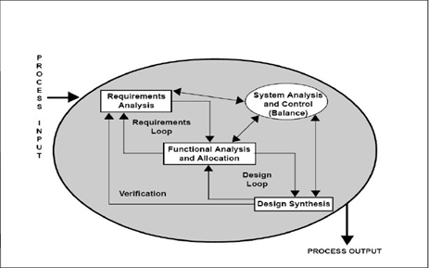
Requirement analysis process

The requirements and the collection analysis phase produce both data requirements and functional requirements. The functional requirements are used as a source of application software design. The data requirements are used as a source of database design.

Key Features

- Enhanced searching engine
- Real-time Pindi Books stock availability
- Local book titles
- Customizable search criteria and results tables
- Intuitive user interface
- Full suite of management reports & potential for custom reports
- Non-book products
- Sales processing and analysis

Committed to Development

We continue to invest a considerable amount of time, resource and money into the development of our Pindi Books software. Constantly embracing new ideas and technologies for an ever changing market, Pindi Books is constantly evolving with it.

Flexibility

Flexibility is an important consideration when investing in a new bookshop system. Your choice must not limit, either physically or financially, your potential to modify and expand along with your business needs.

Pindi Books has been designed with this in mind, and offers a range of inexpensive and often free upgrade routes to expand, customize and adapt your systems to accommodate growth or changes in business priorities.

Customers Comes First

Using Pindi Books’ customer order service allows you to easily record the order with full customer details, including current contact details such as mobile phone numbers and email addresses. Automatically contacting your customer, Pindi Books will send an email or text message to let them know that their order is ready for collection at your shop.

Customers

Customers are the lifeblood of your business. Pindi Books maintains and collates a database of your customers. Not only does this represent a time saving convenience when placing orders, but ultimately offers possibly the most targeted marketing opportunities to you. It collects customer details including addresses, phone numbers and email addresses, as well as ordering history and interests, providing you with the opportunities to create customized promotions. A comprehensive range of reports are available for you to track points and vouchers issued and redeemed.

Stock Control

With core elements such as sales processing, goods-in, returns, bookshop invoicing, and a variety of other utilities Pindi Books is the complete stock control package. You can even add your own product ranges to Pindi Books including non-book items. Many of our customers use their system to maintain and control their non-book stock, such as stationary, music, DVDs, gifts etc.

Bookshop Invoicing

Create invoices, delivery notes and credit notes for any of your customers using this integrated facility. The flexibility of the system allows you to apply overall and/or individual line discounts, with Pindi Books recording the sales transactions and automatically booking out the stock.

You can even customize your invoices, delivery and credit notes to include your own color logs for the header.

Ordering

Creating an order is simplicity itself. From any book search screen you can add the item you are reviewing directly into a new or existing order list. The order lists can be reviewed regularly, and details such as quantities, references and even suppliers changed or swapped about right up to sending the orders.

Orders can be sent using a variety of methods including;
- EDI to Pindi Books and any other EDI enabled supplier
- Teleordering – to any supplier
- Email – to any supplier with an email address
- Printouts

Sales Processing

With each item showing its goods-in, sales, returns and backorder history, you are presented with all the information needed to make a commercial decision about reordering those items. With instant price & availability from Pindi Books online database.

Simplify the Procedure

Goods In

Pindi Books greatly simplifies this procedure as any order supplied by Pindi Bookswill automatically generate an electronic version of the invoice, which the system will collect on demand. Pindi Books will also accept and process EDI invoices from any other supplier offering them.

Once you accept these invoices, Pindi Books will automatically add everything listed into stock for you. Should there be any customer orders included in the delivery, customer slips will be printed ready for you to place inside the front cover.

If your supplier is unable to provide an electronic invoice or delivery note, you can also carry out goods-in using the original purchase order or alternatively by using your barcode scanner.

Backorders

Pindi Books provides you with the latest information on all of your backorders, and you can even mark individual items for chasing or cancellation. This data also links in and updates your customer orders, even when you are making unrelated enquiries.

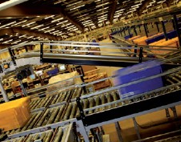

Book Stock In/Out

If you attend many off-site sales events, such as school open days, parent evenings etc., Pindi Books enables you to take stock from the shop, compiling a simple yet detailed list of everything being booked out. Upon you return, you simply book in the remaining stock, and if you wish, Pindi Books can automatically generate the sales data and history for that event.

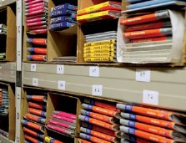

Management Reports

Pindi Books contains a selection of standard reports for analyzing your stock, sales and customers. With reports available to access your current stock holding Pindi Books contains all of the fundamentals to empower you to make the commercial decisions necessary to improve your business plan.

If you have a more specialized requirement, we can even build custom reports for you.

Technical Support

Support for Pindi Books is available through our in-house Pindi Books Support team, Monday to Saturday between the hours of 9am to 11pm inclusive.

Our experienced and friendly team are there to answer any questions you may have and to discuss the many features that Pindi Books has to offer.

Forms

Physical Design

The Physical Design stage has only one purpose: to maximize database efficiency. This means finding ways to speed up the performance of the relational database management system (RDBMS). Manipulating certain database design elements can speed up the two slowest operations in an RDBMS: retrieving data from and writing data to a database.

Logical Design
E.R.D.

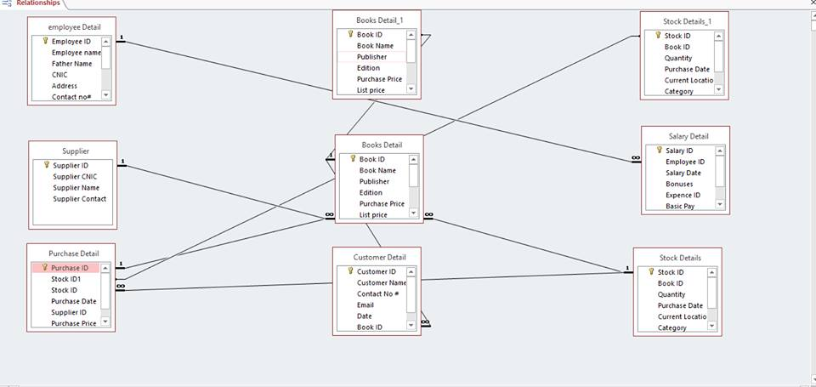

Hardware and Software Requirements

Hardware and Software Environments

Minimum Configuration
Client Workstation Only

Hardware Requirements¹

Machine | x86 (32-bit) | x86-64 (64-bit)
CPU | Operating system dependent | Operating system dependent
Memory | 1 GB | 2 GB
Video | 1024 x 768, 16-bit color | 1024 x 768, 16-bit color
Mouse | Microsoft or compatible | Microsoft or compatible
Hard Disk | 200 MB (no local data set) | 200 MB (no local data set)

Software Requirements²

Operating System | Microsoft Windows XP (32-bit or 64-bit)  Windows Vista (32-bit or 64-bit)  Windows 7 (32-bit or 64-bit).
MS Access | 07,10 or 2013

Conclusion

Nowadays, bookstores are taking important role in guiding and learning process, and to make it reliable they need a strong system that they will make it easier, faster and safer.
Our project, make well connection between pages, roles and lead roles to enter correct information to forms. With this system people can learn and buy books without any misunderstanding that occurs by system of bookstores.
Our aim is to make customers happy and do not make bookstore manager embarrassed against customer. For that reasons, we tried to create strong system. We believe that we achieved our goals and developed our goals by coding.

